**Project Report Implementation and Evaluation of Graph Theory Algorithms**

**Course: Design and Analysis of Algorithms**

**Submitted By:**

**Zohaib Rasool 19K-0228**

**M Hassan 19K-0238**

**Abstract:**

The crucial issue is to deal with the benchmark files that are given in the Project, we need to examine the information from the records and concentrate the focuses and vertices and observe the affiliation that held among them. Following emptying the information, we can diagram the proximity network. Before long it will be something besides difficult to apply various calculations and get our longing results. Since we are using Python so it was okay for us to print the framework and display the desired graphs before and after applying algorithms. We have dealt with the blueprint and tracked down the postponed results of various estimations.

**Introduction:**

We are given the varying data reports of various sizes; the program will push toward the customer for the data record. Later that the customer can pick the estimation of its own will. By then Finally the information that contains by the report that client picked at start will be printed, the proximity matrix will print lastly possible result of estimations will be printed.

**Program Flow:**

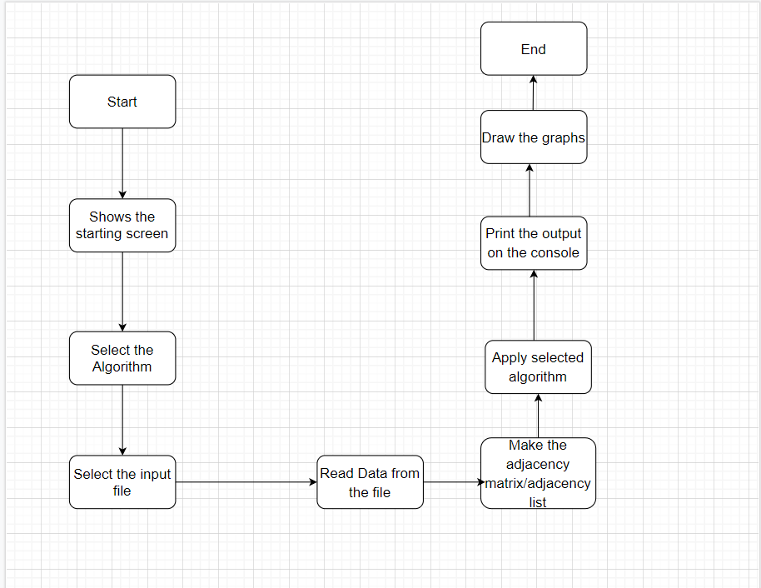

**Experimental Setup:**

The experiment was performed using several python libraries. Networkx and matplotlib were used to draw the graphs by showing the nodes and weights on the screen. UI was built using tkinter library.

**Results and Discussions:**

**10 Nodes :**

Normal Graph :

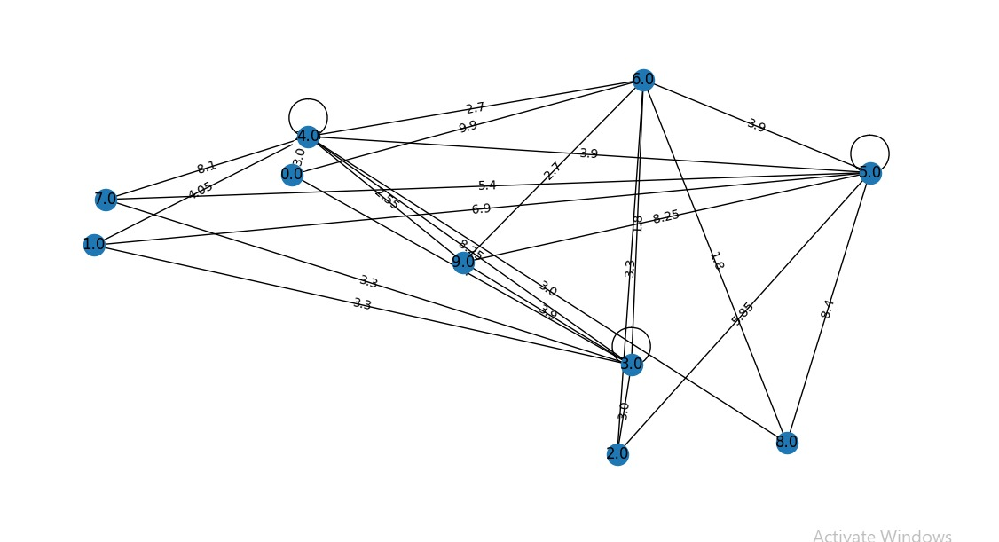

After Applying Prims :

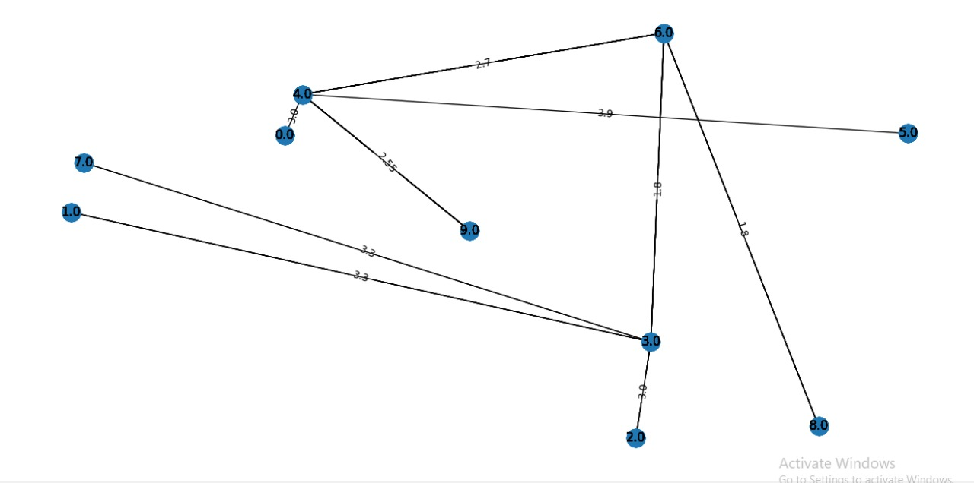

After Applying Kruskal :

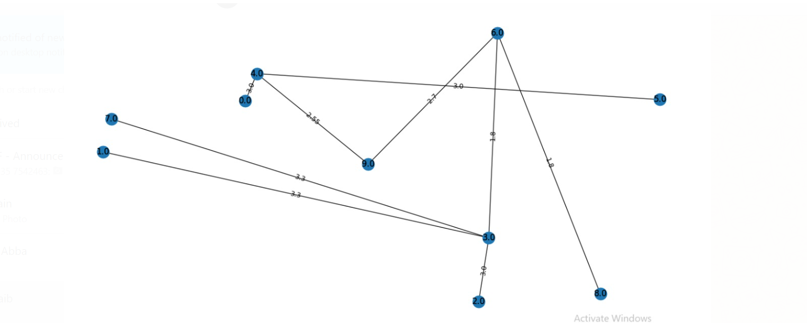

After applying djisktra :

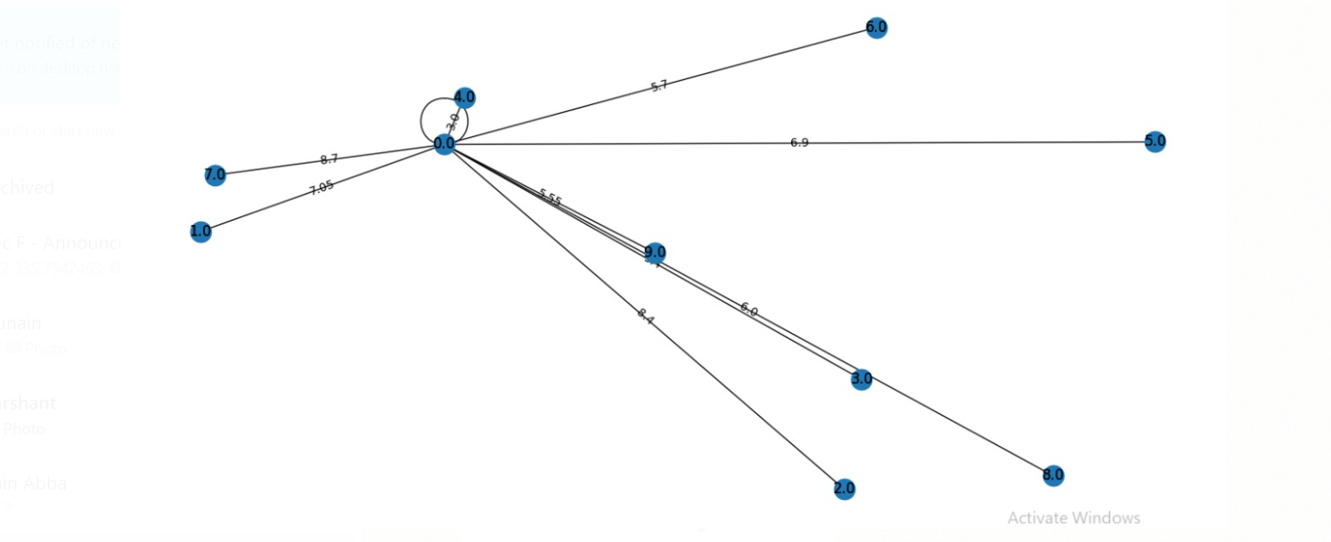

After applying Bellman Ford:

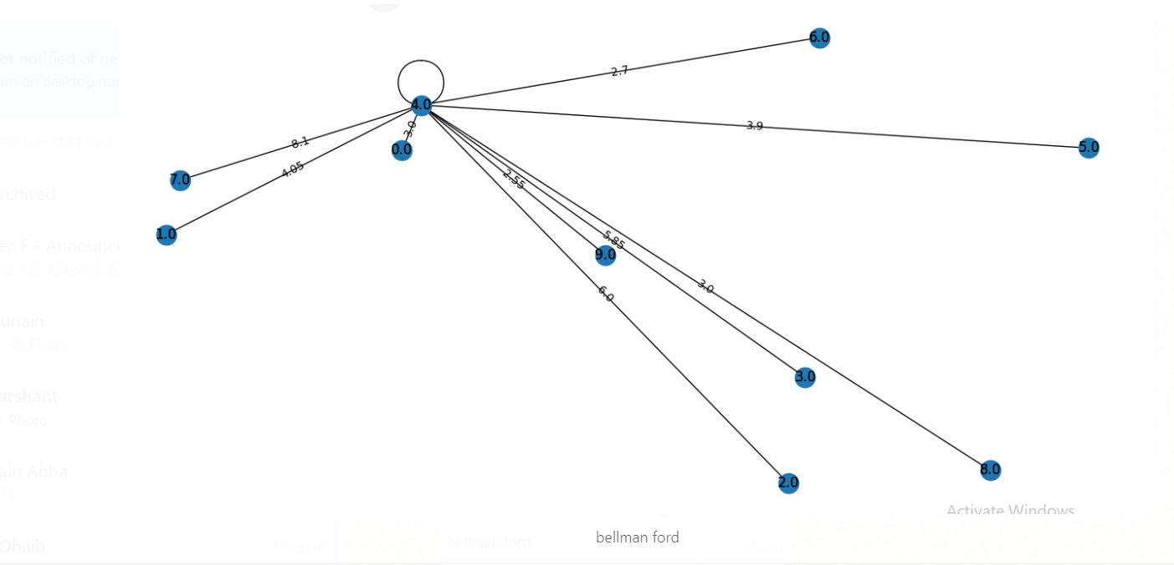

After applying Floyd :

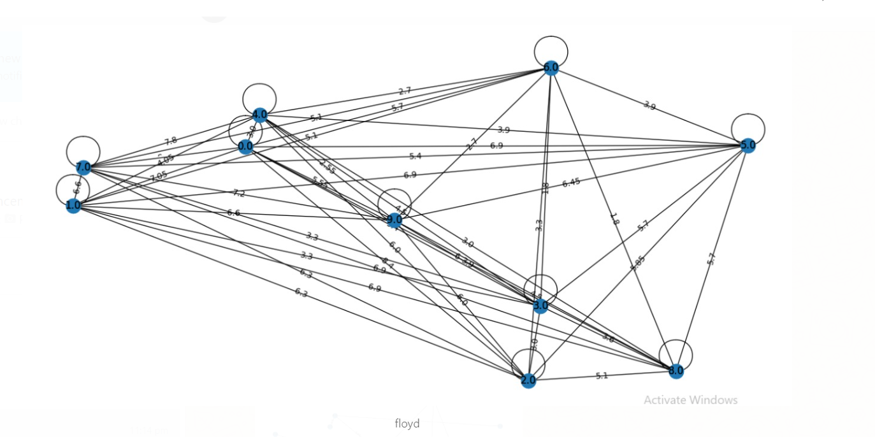

After applying boruvka:

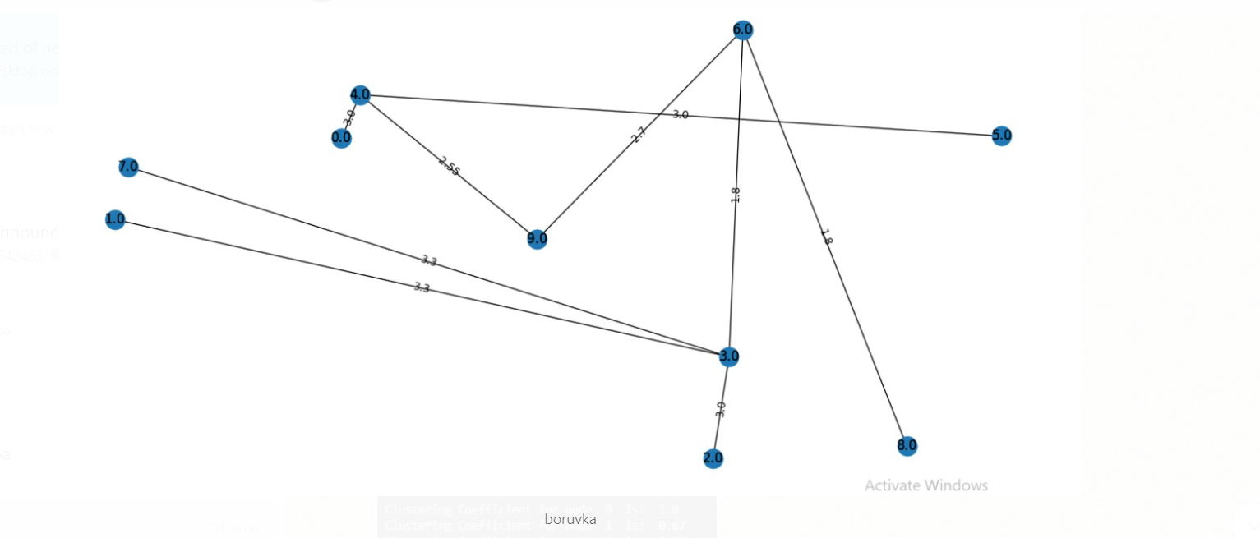

Clustering co-efficient output :

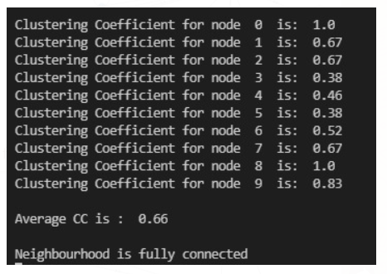

**Conclusion:**

From the above result it might be seen a couple of calculations have same results. By doing all this work, we have learnt how to perform I/O operations on a text file. Furthermore, we have learnt how to plot the graphs using different libraries in python and applying different algorithms on the graph.

**References:**

1. Algorithm Codes taken from different websites like Stack Over Flow, programiz etc.
2. Flow diagram designed on Draw.io
3. <https://networkx.org/>
4. <https://matplotlib.org/>
5. <https://docs.python.org/3/library/tkinter.html>